Paxton Pulse
P a x t o n United Methodist C h u r c h April 2024
2024

Pastor Gary Allshouse (717) 332-2743 gallshouse@susumc.org www.paxtonumc.org
Editor: R. Brian (RB) Wilbur (717) 798-4384 | mamasue11@comcast.net www.paxtonumc.org

Paxton United Methodist Church Exists to Grow and Share God’s Love

Greetings from Pastor Gary

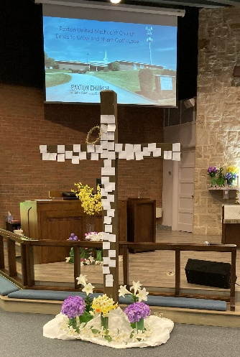
What a glorious time we have had this spring at Paxton Church!! As I have deepened my faith as a Christian, long before becoming a pastor, I have come to love Holy Week; from Palm/Passion Sunday to Maundy Thursday, to
Good Friday, to Silent Saturday. Each day brings a new and different meaning, but it is Easter Sunday that I love the most.

Easter Sunday was a day of great celebration for
He Has Risen, He Has Risen Indeed, Alleluia!!

We have spent Lent talking about our new Vision Statement: Paxton United Methodist Church Exists to Grow and Share God’s Love. Now, what is next?? After Easter, each year we ask that same question; What’s next? As we enter this season of Eastertide, (the church season between Easter and Pentecost) I want to look at our vows that we take as members of Paxton United Methodist Church. In those vows, we promise that we will pray for each other, be present both physically and spiritually; give of our gifts, both of our talents and financially; service to God, the church, and the community; and our witness to the love of God for all people. We will use God’s Vision for us to provide opportunities for those who gather as Children of God at Paxton Church. If you have anything that God has laid on your heart to do and we can help, please let us know.

Brookdale Senior Living – An opportunity to share God’s love.
Pastor Gary has initiated a short service with communion, God’s word and love for our neighbors, the residents at the Brookdale Senior Living facility. The service will be every Monday at 9:30 am. Pastor Gary invites you to join him. Anyone can come.

Student Scholarships – Applications due by Wednesday, May 1
The Cora Martin Weeber Scholarships are available to children and grandchildren, natural or adopted, of Paxton Church members. Applications are available now on the Paxton Church website (paxtonumc.org). Completed applications are due back in the church office by Wednesday, May 1, 2024.

Pastor Gary can be reached at 717-332-2743 and gallshouse@susumc.org His normal office hours are 9 am to 3 pm Monday through Thursday. Please call ahead to ensure he is available.

Sunday Services are 9:15 am in the Sanctuary. Worship is in-person and live on Facebook Live on anytime at www.facebook.com/paxtonumc. Communion is the first Sunday of every month.
A children’s nursery is available.

Bible Study begins at 10:30 am each Sunday, in Room 2 across
from Pastor’s Office. Beginning April 7, the focus will be on
prayer and praying.

In all your ways acknowledge Him,
and He will make your paths straight.
Proverbs 3:6

Book Study Group meets at 10 am every Wednesday at the Peach Tree Restaurant. They are currently discussing The Rock, the Road, and the Rabbi by Kathie Lee Gifford (with Rabbi Jason Sobel).

Choir Practice 7 pm on Wednesdays. Pilates 4 pm on Wednesdays.

Sew for Peace 9 am Thursday. In coordination with the Palm Sunday service of laying down the cloaks, a clothing delivery was earmarked for the Latino Hispanic American Community Center in Harrisburg.

Golden Agers meets at 12:30 pm Tuesday, April 9th for lunch, bingo, and fellowship. Next trip is the
Williamsport Chocolate Lover’s Tour (June 4, $126). Check bulletin board for other upcoming trips. Family, friends -- everyone is welcome. Contact Dotty Sellers.

Daystar Dinner Paxton Church will serve a dinner on April 21st at 4 pm, to Daystar residents, family, & friends. Volunteers are always welcome to help in the kitchen and serve. Contact Bill Toner.

Easier Eggs Thank you to everyone who contributed their time to make our easter egg program a success. We
had a lot of fun, and made over 11,000 eggs with a net profit of $9,000 which goes into the General Fund.

AA Meetings at 6:30 pm Mondays, Tuesdays, and Friday. Al -Anon 6:30 pm, Tuesdays in Room 103.

Prayer Requests -- Pray the Lord will bring comfort, healing, and his love to all people. See weekly bulletin for those currently asking for prayers.
Prayer Chain – Anyone who is interested in joining the prayer chain should contact Kathy O’Brian (kobrian53@gmail.com )or RB Wilbur (mamasue11@comcast.net) with your current email address and phone number so we can compile a complete list.

PEANUT BUTTER Challenge a BIG success.

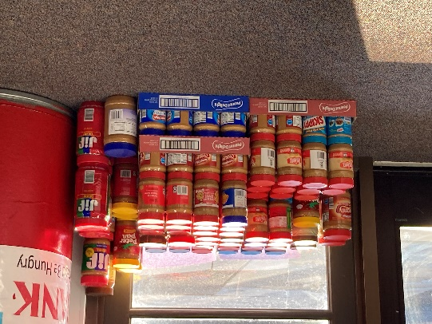

The Paxton congregation contributed 200 jars of peanut butter in the district-wide United Methodist challenge to help our brothers and sisters. The Hanna Food Pantry in Susquehanna Twp. and Manna Food Pantry in Penbrook will each receive 100 jars of peanut butter.

Check out our beautiful website to learn more about us – www.paxtonumc.org

